**New Staff user to staff profile page – process**

**In order to be able to have a great user experience when they log in we need to ensure that it makes sense to the user.**

At the moment a user would go to (sign up page) and sign up.

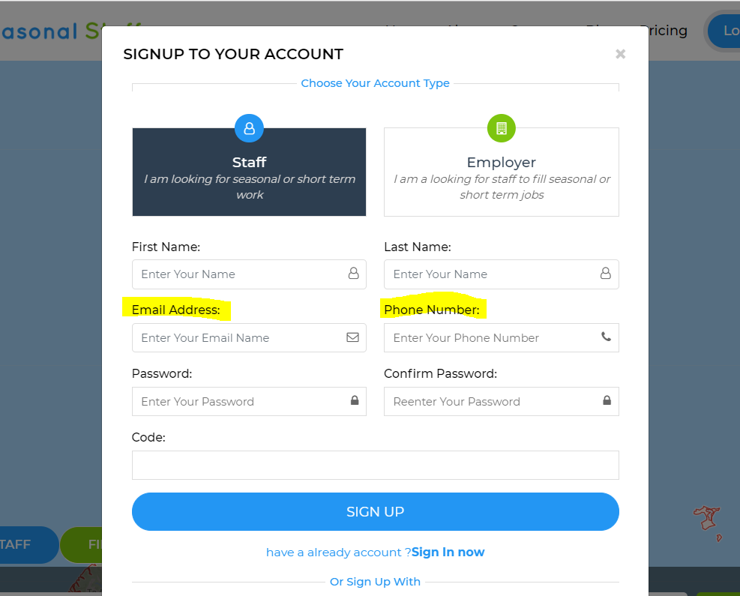

Once they had registered they would then be shown this page (which tells them it was successful but no instructions on what to do next.. (I have mentioned an update on this on a previous email)

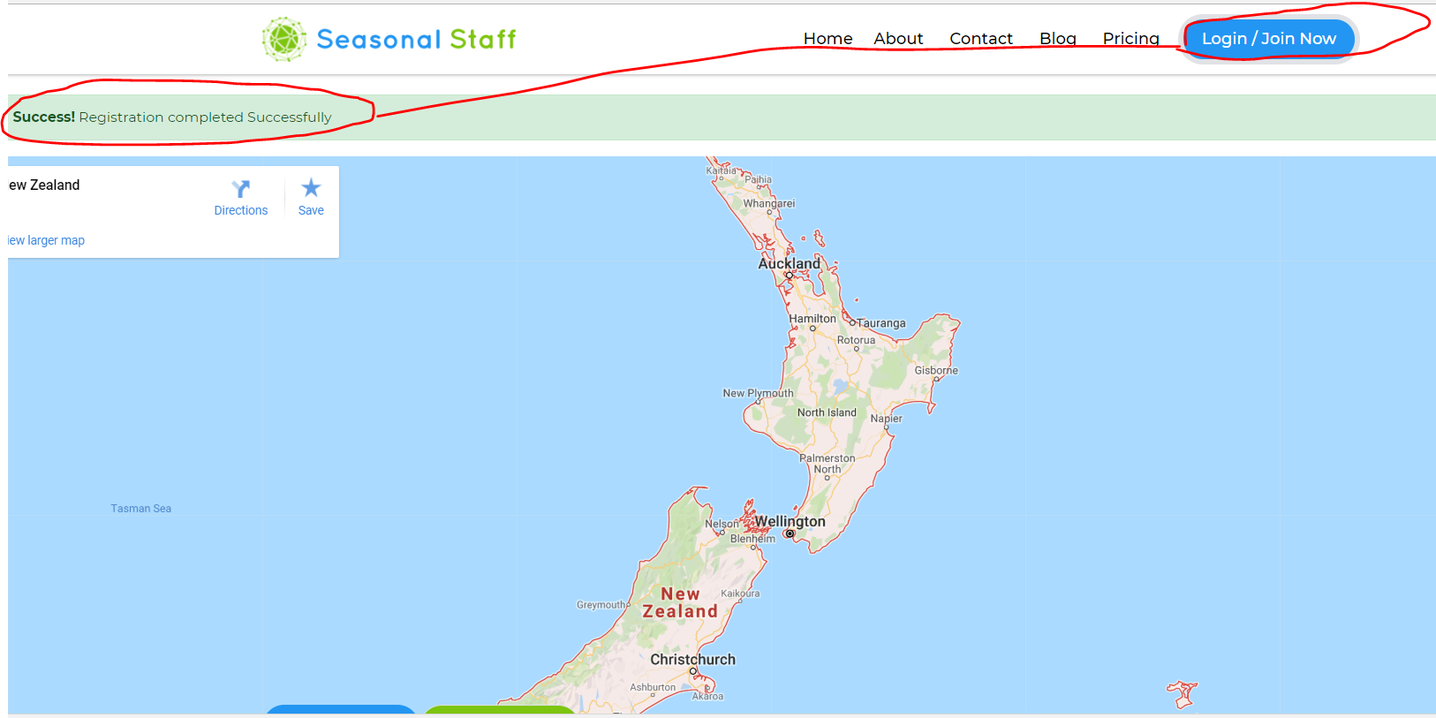

They then have to log in and come to a screen that shows the profile picture and a Dashboard icon and no instructions what to do or where to go.

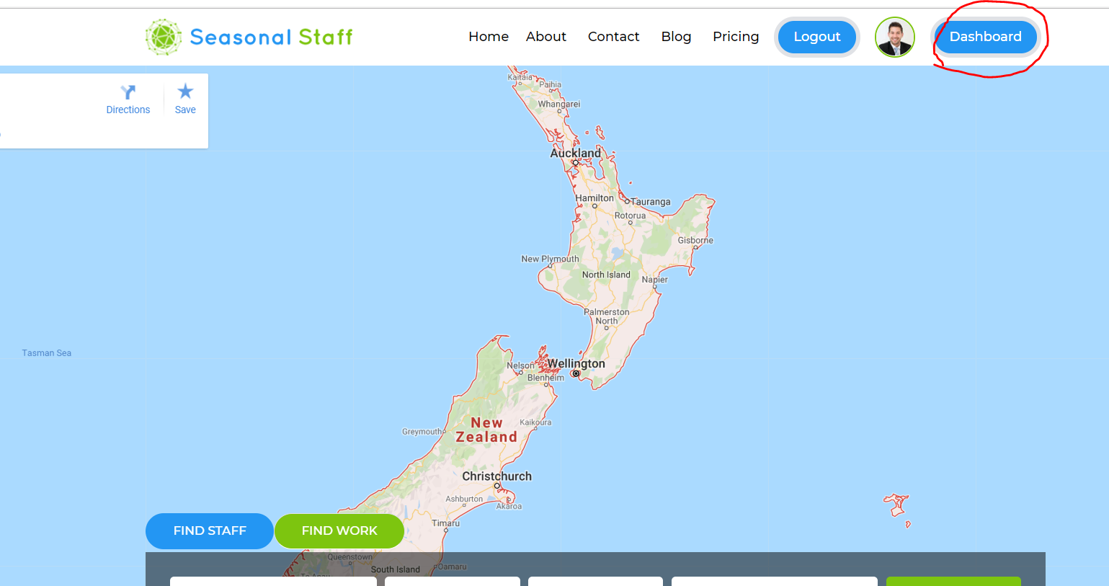

I then assume they click on the Dashboard icon and come to this page.

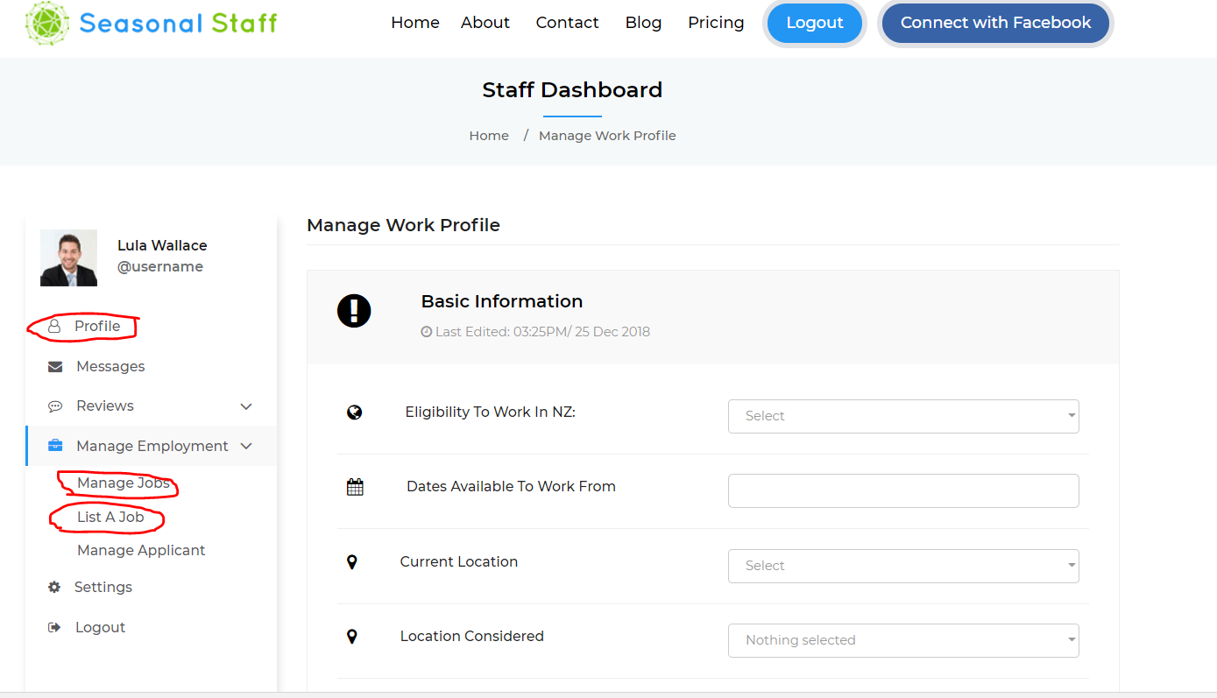

**This all seems very long winded. Can we please have the following process.**

Staff member Register with Seasonal Staff (some of this information can pre populate other areas of the profile)



Once registered they are told registration was successful and directed to log in (this is a first time thing) once they are registered they and log in they are directed to the next screen.



Once they log in – they are always directed to their profile page.



It is really important to get this part correct. For the following reasons.

We rely on it being easy to use.

We also know that we will have a lot of older peope using our website.